PSST Annual Convention 2016 Lahore
Application of Milling through Technological developments
Induction - Operation - Performance
An experience at Ramzan Sugar Mills
By
Mohammad Sarfaraz Khan
General Manager (Plant)

Introduction
In the recent era of technological developments, milling itself is an area where greater opportunities are used to optimize efficient capacity utilization. However, Ramzan Sugar Mills since last 5 - 7 years incorporated latest technologies at their plant to ensure energy efficient measures. Primarily, Falling film Evaporators,Vapor line juice heaters, Molasses Conditioners, Auto – condensing system, Partial electrification at Mill drives& Induction of Two Roller Mill are significant. In order to proceed as trend setter, RSML executed their season 2015-16 with synchronized state of art bagasse base Cogeneration plant of 62.4 MW capacity operated under 110 Bar / 540 ^{O}C operational parameters which economize the operation in great extent.
Induction & activities
- HD Cane Cutter 1676 MM swing diameter.
- HD Shredder 1810 MM swing diameter driven by Motorized / VFD application on dual – end.
- Largest size Millmax 55 X 102 inch unit as Mill No.1 by replacement of 42 X 84 inch Mill
- Existing Roller shell area enhance by 10.90 % with revision from42”X 84” to 45”X 88”
- Incorporation of Lotus Rollers at last mills
- 35^{O} first Mill Roller grooving along with 5 mills of 50⁰
- Comprehensive electrification of Mill house with VFD’s.

Cane Preparation
Description HD Cane Cutter HD Cane Shredder
- Capacity (Design) 625 TPH (with allied units) 625 TPH (15000 TCD)
- Swing diameter (MM) 1676 1810
- Equipped with (KW) 1200 (Motor) 2X2500 (Motor – VFD)
- No. of Knives 80 each of 16 KG 100 each of 27 KG
- Speed (RPM) 600 1000
- Tip Velocity (M/Sec) 52.65 94.24
- Momentum (Kg – m /Sec) 359094 1979208

HD Machines impact over Density& subsequent Capacity

Season | Presented Cane Density (Kg/ M³) | Prepared Cane  Density (Kg/ M³) | CPI % | Crushing enhanced (TCD)
2015-16 | 125 – 150 | 270 – 300 | 89.50 | 1200 – 1300(Avg)

Relationship of Chute level Vs Density at Mill Feeding chute
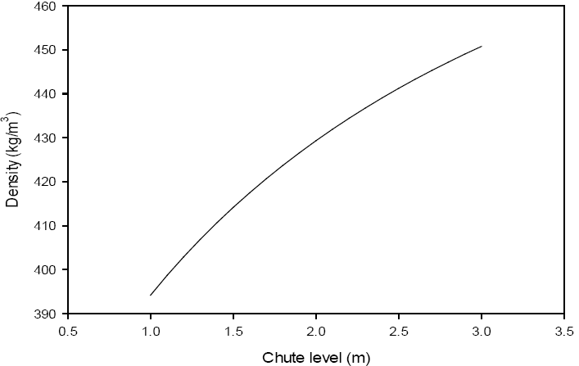

The advantage of density produced by inducted machines reflected as follows,

(*Induction of 2 Roller Millmax 55” X 102”, ** HD Cutter 1676, Shredder 1810 MM swing diameter)

Cumulative data Comparison CPI – First Mill Extraction – Over all extraction
Season | Cane Preparation Index % | First Mill Extraction % | Over all Extraction  (Reduced) %
2013-14 | 87.900 | 62.250  (Conventional 3 - R Mill with U.F) | 95.71
2014-15 | 87.600 | 70.900* | 95.950
2015-16 | 89.500** | 71.650* | 95.680

Comparison of Capacity enhancementVs Result(3- Years)

Seasons | Capacity Utilization (%) | Imbibition  % Cane | Bagasse Pol  % | Bagasse Moisture % | Calorific Value  Kcal/Kg
2013-14 | 72.19 | 31.070 | 1.648 | 51.87 | 1,715.30
2014-15 | 71.72 | 30.250 | 1.754 | 52.10 | 1,704.15
2015-16 | 82.60 | 27.350 | 1.872 | 51.62 | 1,725.99

Comparison of Improved Cane Preparation Vs Power consumption

Installed Power  KW | Consumed Power  KW | Percentage Consumption  (%) | Absorbed Power (KW)/TFH | Performance (%)
8,200  3 Cutters + HD Shredder (Dual drive) with VFD | 4591.21 | 56 | 65.59 | 89.50

Comparison of Power Vs Cane Milling

 | Installed Power  (KW) | Consumed Power  (KW) | Percentage Consumption (%) | Absorbed Power  Tons Fibre /hr. | Performance (%)
 | 7,200  1200 X 6 Mill with VFD | 3536 | 49.11 | 50.51 | 95.68

Revised Roller Grooving & Impact over Capacity & performance
Roller Grooving principally, design aspect but its revision can dual beneficial to enhance capacity with extraction. However, Messchaerts significantly contributes drainage with reduce angle as reflected at Mill # 1. Keeping in view that bagasse doesn’t go all the way down thus leaving free spaces. At that time juice under pressure has tendency to go down through channels, subsequently with additional depth leads to improved extraction. However, 2 – 5 % capacity enhancement with 0.3 – 0.5 %extraction can be realized with grooving itself. Status of Mill groovingat RSML as follows,
Description | Mill Configuration | Grooving Pitch |  | Groove Angle | Groove Depth | Top Roller Status | Mill Speed
1 | 55" x 102"  (Millmax) |  | 60 mm | 35° | 45 mm | Conventional Roller | 4 RPM
2 | 45" x 88"  (4 –Roller Mill) |  | 63 mm | 50° | 30 mm | Conventional Roller | 4.81 RPM
3 | 45" x 88"  (4 –Roller Mill) |  | 63 mm | 50° | 30 mm | Conventional Roller | 4.58 RPM
4 | 45" x 88"  (4 –Roller Mill) |  | 50 mm | 50° | 22 mm | Conventional Roller | 5 RPM
5 | 45" x 88"  (4 –Roller Mill) |  | 50 mm | 50° | 22 mm | Lotus | 5.27~5.5 RPM
6 | 45" x 88"  (4 –Roller Mill) |  | 50 mm | 50° | 22 mm | Lotus | 5.27~5.7 RPM
Roller Grooving Capacity Assessment:-

T = C $\sqrt{N}$ D²LN X$\frac{0.2+0.8}{Sin(A/2 )}$
123F
Where,
T = Grinding rate TPH
$\sqrt{N}$ = No. of Rollers in Tandem (3 per Mill)
T = RPM of Mill
L = Roller Length in (Feet)
F = Fibre per unit Cane
D = Mean roller diameter in feet (Half groove depth)
A = Angle of grooving
C = Tandem Configuration factor
1 Set of Knives = 1.15
2 Set of Knives = 1.20
2 Set of Knives + Shredder = 1.26
2 Set of Knives + Shredder + Vertical feed chutes of min 2.5 meterHeight + under feed roller = 1.32
2 Set of Knives + Shredder+ Vertical Chutes + Pressure feeder rollers = 1.45

Roller size enhancement from design aspect
Roller Shell size enhance from 42”X 84” to 45”X 88” which ultimately increased 10.90 square Inch surface areawhich facilitated additional crushing. However, induction of Lotus Roller at last Mills leads to value added activity which partially contributed moisture reduction by 0.48 % as an average for the season 2015-16 as compared to season 2014 -15

Plant utilization Impact
Seasons | Over All
2013-14 | 72.19
2014-15 | 71.72
2015-16 | 82.60 (10.88 % Rise)↑

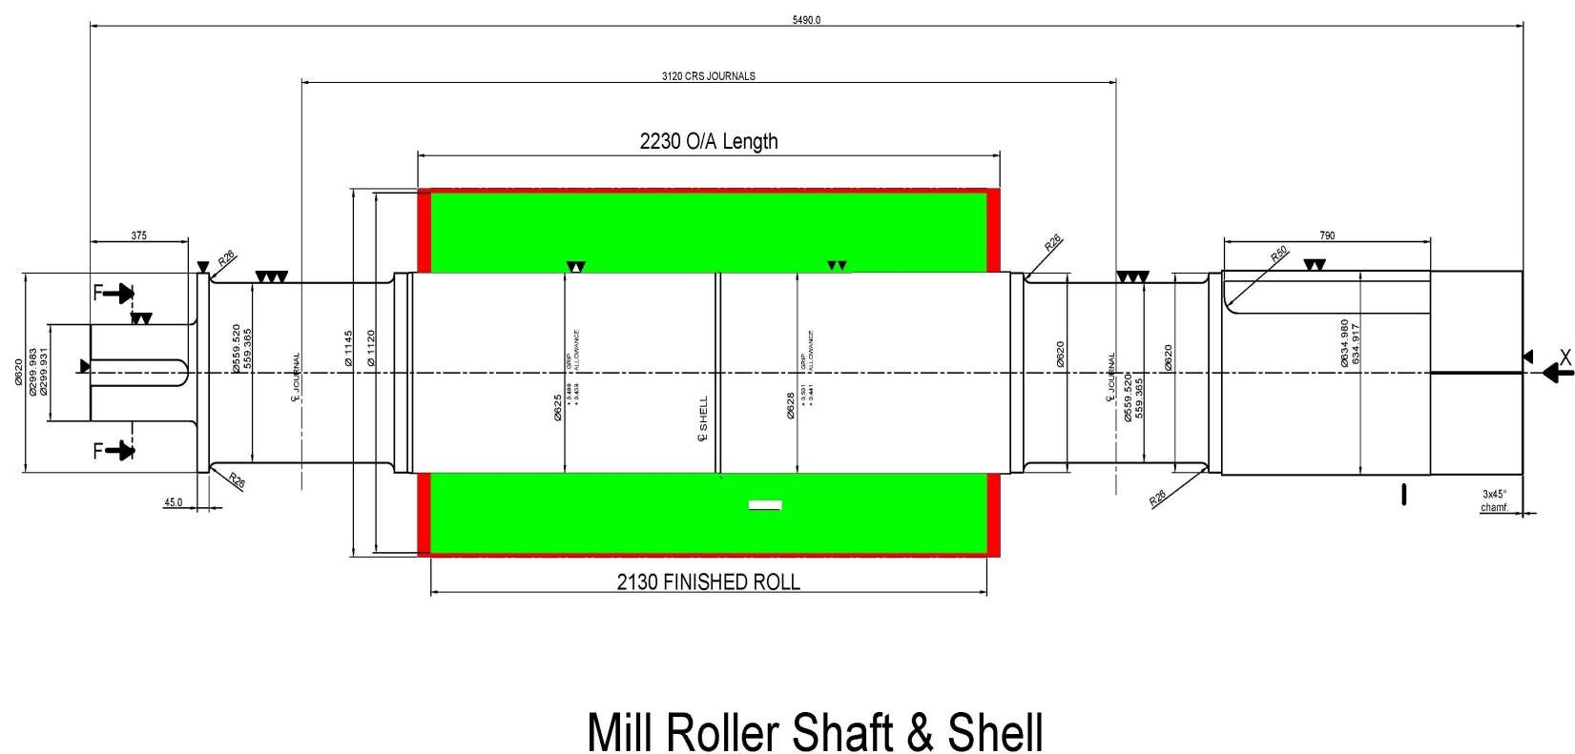
Mill Drives Electrification
Serial No. | Equipment Description | Installed Power (KW) | Installed VFD Power (KW) | Power Consumption (KW) | Consumption (%)
1 | Cutter 1 | 1200 | - | 700 | 58.33
2 | Cutter 2 | 1000 | - | 800 | 80
3 | Cutter 3 | 1000 | - | 900 | 90
4 | Shredder (Master) | 2500 | 2850 | 1174 | 46.96
5 | Shredder (Follower) | 2500 | 2850 | 1017.29 | 40.69
6 | Mill Max  55" x 102" | 1200 | 1750 | 730 | 60.83
7 | Three Roller Mill with Under Feed  45" x 88" | 1200 | 1750 | 482.68 | 40.22
8 | Three Roller Mill with Under Feed  45" x 88" | 1200 | 1750 | 600.02 | 50
9 | Three Roller Mill with Under Feed  45" x 88" | 1200 | 1750 | 499.87 | 41.65
10 | Three Roller Mill with Under Feed  45" x 88" | 1200 | 1750 | 593.66 | 49.47
11 | Three Roller Mill with Under Feed  45" x 88" | 1200 | 1750 | 629.33 | 52.44
Total |  | 15400 |  | 8126.85 | *52.77 – 55.50 %  Operation variation ranges during operation
Concluding achievements:-
- Power consumption for specific mill house 9.369 MW @ 12000 TCD including other integrated drives
- Power consumption of Plant remained 12.5 MW @ 12000 – 12300 TCD
- Steam consumption to produce 12.5 MW equals to 46.84 TPH through HP Co generation @ 5 KG/KWH by utilizing 110 bar pressure / 540 ^{O}C technologies.
- There was no sinking at operation was observed due to stabilize voltage in comparison of Turbine
- Suitability to operate Mill at Low RPM i.e. 4 RPM which remained key factor to optimize results at higher rate of crushing leads to enhance average crushing by 1200 – 1300 TCD
- Steam % ranges 44 – 45 % on cane during activity.
- 0.48 % moisture reduction leads to improve bagasse efficiency at HP Boilers
- First Mill extraction raised by 0.75% contributed by narrow groove angle, reduced speed, revised setting & optimized available drive power utilization.

